The Falcon Flier

Together We Empower

Today & Tomorrow

June 23, 2020

Message from Dr. Burks...
Dear Fulton Families,
HAPPY LAST DAY OF SCHOOL!!!! There are no words to express the feelings that the 2019-2020 school year has evoked. We have had all the feels – joy, excitement, sadness, worry, anger, love. But through it all, we have had all of those feelings together. This morning as I viewed the 5th grade promotion, it reminded me that although we are apart, we are most definitely connected and stronger together.
The end of this year is bittersweet. We will say goodbye to students and families who will be joining the Hammond Elementary School community next year, 5th graders who will be matriculating to middle school, families who may be moving to other schools and states, and staff who will be embarking on new adventures.
Please join me in wishing the following staff members the best of luck:
- Ms. Alon Wakefield will be retiring. We appreciate her 30 years of service that she has dedicated to our students, families and colleagues throughout the years.
- Ms. Jennifer Laycock will be moving closer to her family out of state.
- Mrs. Elissa Augusti will be pursuing a career closer to home so she can spend less time on the road and more time with her family.
- Mrs. Jodi Cozzone will be pursuing a teaching career in another County.
- Mrs. Maisoon Kupisch will be returning to middle school to teach math, here in Howard County.
- Mrs. Teresa Pickett will be moving on to explore other career paths.
- Mrs. Chelsea Salzberg will be staying home to spend more time with her baby girl.
- Ms. Salma Waheed will be moving on to explore other career paths.
- Mrs. Kimberly Waldron will serve as a Birth to Five Early Intervention Services Resource Teacher, here in Howard County.
- The following staff members were surplussed due to our reduction in numbers and will be joining another lucky Howard County School:
  - Mr. Dale Allen
  - Ms. Kristi Hedrick
  - Mr. Tim Incavido
  - Ms. Gloria Nam
  - Mrs. Sara Solomon
  - Mrs. Danielle Wood
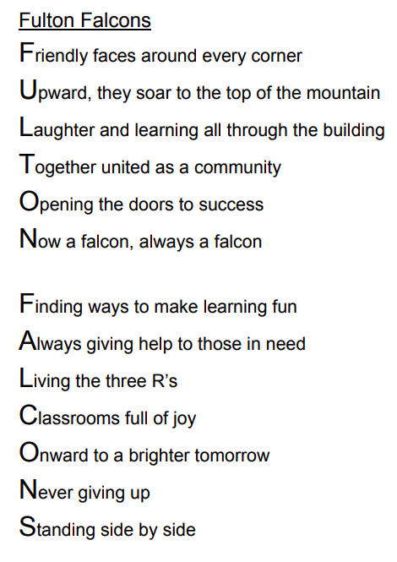

Thank you Mrs. Loman for sharing your poem! Mrs. Loman is a parent whose family will be attending Hammond Elementary School next year. We will miss all of our students and staff, no matter where next year takes you- Now a Falcon, always a falcon!
I will be in touch as we weather this summer of uncertainty. Please hug your children for us, stay safe, and have an incredible summer!
Warmly,
Dr. Burks

Announcements

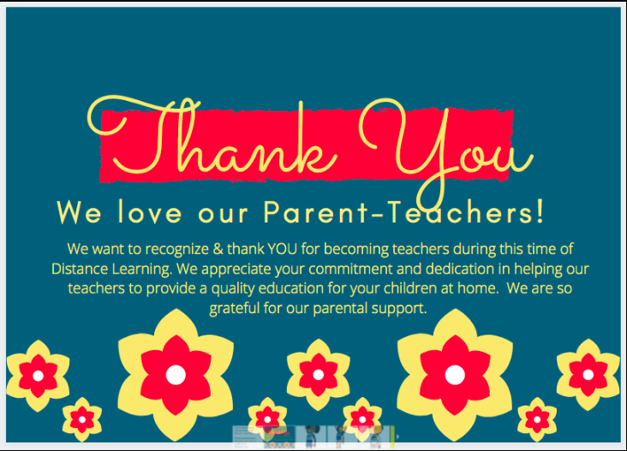

FES Summer Fun with Admin
Have you ever heard of Flat Stanley? Stanley was flattened overnight, which made it easy to jump into an envelope and be mailed to family and friends across the World. Grab your flattened FES Admin and have your child take us on all of their summer adventures! We can't wait to see what adventures we join you in this summer!
Dr. Burks Mrs. Caroland Mrs. Brickner
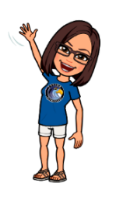
Summer Adventures with Admin 2020.pdf

Report Cards & Incomplete Grades
Today, June 23rd, you can access your child's 4th quarter Report Card via Synergy.
If your child has received one or more Incompletes during Quarter 4, your child has the opportunity to make up Quarter 4 assignments before September 15, 2020. Work completed on or before that date will earn a Pass. HCPSS will share materials available for students who received Incompletes to complete this summer. Your child can complete the materials independently or as part of the Academic Intervention Summer Program. If your child is able to join the summer program, please email Mrs. Molly Caroland, molly_caroland@hcpss.org, who will help you enroll your child. Please know that after September 15, 2020 all remaining Incompletes will become Not Available or NA.

HCPSS Seeks Stakeholder Feedback on 2020-2021 School Year
Many of you have inquired 'how can you provide feedback to the County on your experience during Distance Learning', here is your opportunity! Yesterday, the County sent out an email to all stakeholders sharing links to surveys, targeted to each group. You are encouraged to share your voice by Wednesday, July 1st, the feedback will help guide the solutions for the 2020-2021 school year.
Students
- Grades 3-5 (I encourage you to engage your children in completing this survey- their voice matters!)
Parents/guardians
- English
- Chinese, 中文
- Korean, 한국어
- Spanish, Español

Mark your Calendars
As a reminder, the first day for students for the 2020-2021 school year is Tuesday, August 28th.

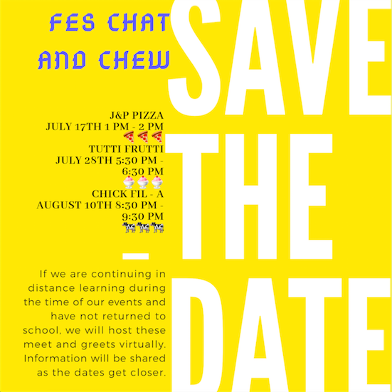

Enrollment Information
Parents/guardians of new incoming students and those entering kindergarten in the 2020-2021 school year (who are not already enrolled) can enroll using our online portal, followed by completion of the registration process via a virtual meeting. If you have not began the process yet, please use the details on our website to start registration.

5th Grade Thank You
The 5th grade team would like to give a HUGE shout out to all of our parent volunteers that have helped us throughout the year. A special thank you to all of our room parents as well as those on our End of the Year Committee who assisted with hosting amazing activities for our 5th grade scholars! Thank you! We hope you have a wonderful summer!

HCPSS Summer Free Meal Service
The Howard County Public School System announces its free summer food service program to meet the growing need to feed hungry children and families in Howard County and fill the nutritional gap over the summer months. For more information, please check out the website.

Volunteers!
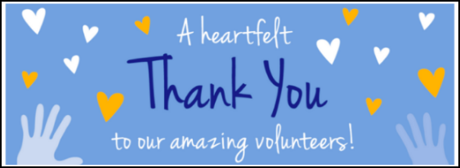
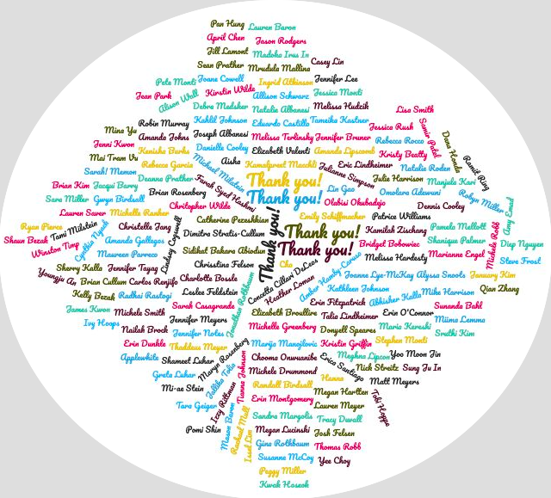
Full Calendar

Curriculum Corner

Student Access to Lexia Core5 and DreamBox
Elementary students will have access to DreamBox Learning and Lexia Core5 throughout the summer. Students are not required to work with either learning platform, and their progress will not be monitored by teachers. The Parent portal for DreamBox will continue to be available to review student progress. For Lexia Core5, review the Student Dashboard- the green bar at the bottom of the screen fills from left to right to show progress in each unit. If you choose to have your child work with these tools over the summer, we encourage you to limit use to the recommended amount of 15-20 minutes per day. For technical support during the summer, please use the following contact information:

DreamBox Technical Support Contact Information
Email: support@dreambox.com Customer service: 1 (877) 451-7845
Lexia Core5 Technical Support Contact Information
Website: http://www.lexialearning.com/support.
Email: support@lexialearning.com Customer service: 1 800-435-3942
The following links provide additional mathematics and language arts resources for students:
- English Language Arts Resources
- Mathematics

Canvas Access
Students and parents will continue to have access to their 2019/20 regular school year courses and content in Canvas until 11:59pm on July 3, 2020.

Summer Reading BINGO Challenge
Looking for ways to boost you child's literacy skills over the summer? Challenge them to complete their grade levels BINGO Board
- Kindergarten Summer Reading BINGO.pdf
- 1st Gr Summer Reading BINGO.pdf
- 2nd Gr Summer Reading BINGO.pdf
- 3rd Gr Summer Reading BINGO.pdf
- 4th Gr Summer Reading BINGO.pdf
- 5th Gr Summer Reading BINGO.pdf

Summer Reading Lists via HoCo Library System
As part of the A+ Partnership with the Howard County Library System, summer reading lists developed by HCPSS library media specialists and Howard County Library System Children’s Instruction and Research staff are available for students in all grade levels. Books included are just a sampling of what students may enjoy reading during the summer. Students are encouraged to check out other books by the authors included, as well as explore additional book topics at the library.
Recommended lists for all grade levels are available both in schools and online.
All families are also invited to participate in the summer reading challenge to help make a difference In this challenging time for so many in our community. Beginning June 1, log books and activities in one of three games: Imagine Your Story (for infants to age 10 and ages 11 to 17) and Read for Good (for adults).
Instead of physical prizes upon completion, you will earn a donation to Community Action Council of Howard County.* Visit hclibrary.org/summer to get started. New activities and challenges added each week online, so keep reading and checking in!
Register online: http://hcls.readsquared.com/
Sponsored by Friends & Foundation of HCLS.

Bully Buster Bulletin

PBIS Update
Please tell returning students to KEEP their Falcon Feathers for next year. Stay tuned on you can use them in the fall!
Counseling Connection Newsletter - The HCPSS Elementary School Counseling Connection Newsletter is a great resource for students and parents to read together. Included in this latest issue of the School Counseling Connection newsletter are self-care ideas and fun activities for home.

Connect with our PTA
Our PTA is a terrific partner to our school. Learn about the many ways they help support Fulton and strengthen our community- as well as how you can get involved.
