The Falcon Flier

Together We Empower

Today & Tomorrow

January 30, 2020

Message from Dr. Burks...
Dear Fulton Families,
Happy New Year! We are in a new year and new decade! I hope everyone had a restful and joy filled winter break. We have started the new year at full tilt, with many activities to include Winter Concerts and the Spelling Bee. We are proud of all the students who participated in these events as well as the staff and community who helped make this happen!
Additionally, we are officially embarking on the 2nd half of the 2019-2020 school year with 3rd quarter beginning yesterday, January 28th. Let's continue to partner to make this the best year yet of our students!
Warmly,
Dr. Burks

Announcements

What is your preferred mode of communication?
We are striving to improve our communication with our families and community. In order to do that, will you please provide us feedback on the best way to communicate with you by completing this brief form. Thank you in advance for your feedback!

February Conferences
February Parent-Teacher Conferences for Math will take place on February 13 and 14. Conference scheduling will be open to parents beginning on January 30th and will close on February 11th.
In order to set-up a conference with your child's teacher, log-into the Family File and follow the directions below:
- Log into HCPSS Connect.
- In the Navigation pane, select Conference and click the Parent Scheduled Conferences link in the top right corner to schedule conferences.
- Select a time option for each class listed. The conference will be saved automatically. Once you select a time option, all other time options for that class will become unavailable. To select a different time option, clear the first checkbox and select a new option. If you have more than one child, select the next child in the banner across the top. If you need help navigating the online system, please contact the FES front office staff at 410-880-5957.

Summer Program Opportunities
Each summer, HCPSS offers learning experiences and educational opportunities through a variety of programs and classes. For a preview of the each of the programs, please review this document and for more detailed descriptions of the variety of programs offered, please click here.

Free Eyeglasses and Exams
Free eye exams and glasses will be offered at Howard High School on Saturday Feb 29 and Sunday March 1. Slots are limited. Services will be provided on a first come, first served basis, appointment preferred. In case of schools being closed due to inclement weather, the clinic make-up dates will be the weekend of March 7-8. To sign up, please call 301-693-4469.

Spelling Bee Winner

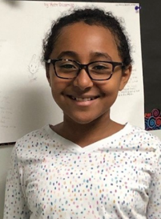
P-L-A-S-M-A! That was the word that fifth grader Abigail Zecharias spelled correctly to win the Fulton Elementary School Spelling Bee, for the 2nd year in a row! Congratulations to Abigail, and to all of the participants of a thrilling Fulton Spelling Bee.

Young Authors Contest
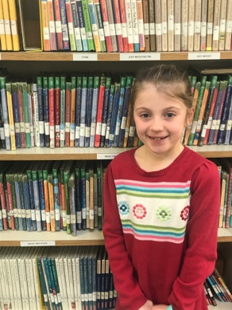
We want to congratulate Lillian Nipper! She won Honorable Mention for her short story, "Sticky Note" in the Young Authors contest at the County level. We are so proud of you, Lillian!

1st Grader highlighted in the Baltimore Sun
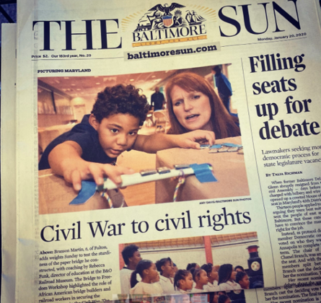
Branson Martin, a 1st grader here at FES, was highlighted on the first page of the Baltimore Sun for his engagement in MLK, Jr. activities at the B&O Museum. We are proud of you Branson!

Kindness Week
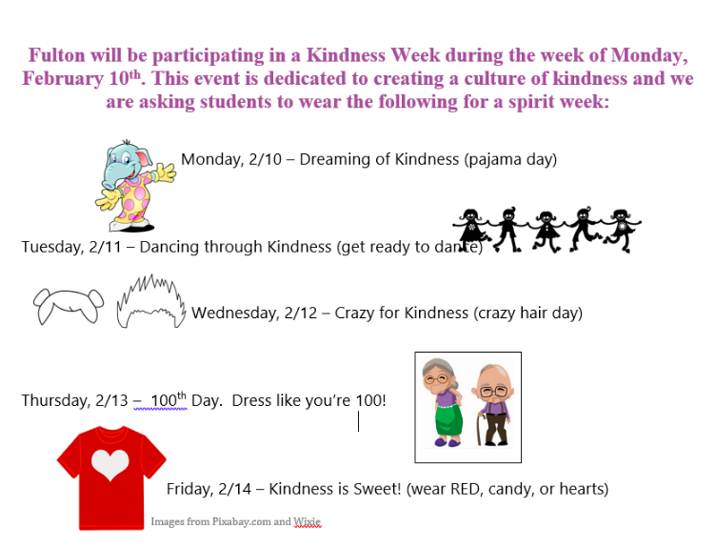

Black Out Day
Unplugged: Black Out: Friday, February 7th
Students and staff wear all black to remember to unplug from electronics and come to “Unplug Night.”

Fulton Families are cordially invited to...
Fulton’s Unplugged Night
Hosted by the Fulton Wellness Committee
When: Friday, February 7th from 6:00pm-7:30 p.m.
Who: All Fulton families and teachers
What: A schoolwide game night where you’ll get to know your school community while playing your favorite games
How it works:
Bring some of your favorite board, card, or other non-electronic games (with your names on them) to play with other Fulton friends. As a specialist in your game’s instructions, you will be in charge of teaching and leading other Falcon’s gameplay. We will have tables set up for you to teach your game and play.
For groups that have room for additional players, we will have a flag system to indicate that there is space for more participants. If you’re looking to play a new game, look for other specialists with a flag, indicating that they need another player. You do not need to have a game to come, and are welcome to join a specialists' game if there is room. We will have recess board game available.
Some of your teachers will be specialists for their own favorite games and will have stations available
Children must be accompanied by adults for the duration of the evening. No running, hitting, or other disruptive behaviors will be permitted.
To RSVP, please fill out the following link so we know how many tables to set up: https://tinyurl.com/fesunplugged
Yearbook Orders
It’s yearbook time again! Order your 2019/2020 Fulton Elementary Yearbook today! Online orders only. To order, simply go to https://www.strawbridge.net/ and use the school code YB1120070. Choose a hard cover yearbook for $28.00 or a soft cover yearbook for $22.00. Don’t miss out, order today.
The deadline for all orders is February 28, 2020.

Being Prepared for Inclement Weather
In order to be prepared for unscheduled closings during these months, or in the event of an emergency closing for any reason, please sign into your Family File at https://www.hcpss.org/connect/ to check how your child is scheduled to go home in the event of an UNSCHEDULED CLOSING. Please make sure that it reflects how you want your child to be dismissed in these situations. In addition, please have a conversation with your child about this if it is different than their normal dismissal procedures.

Schedule Update- Mark your Calendars
Looking ahead, Tuesday, February 4, 2020 schools will be closed due to the special primary election to fill the 7th congressional district seat vacated following the passing of Rep. Elijah Cummings. Please mark your calendars so you can plan accordingly.

The Kindness Pantry
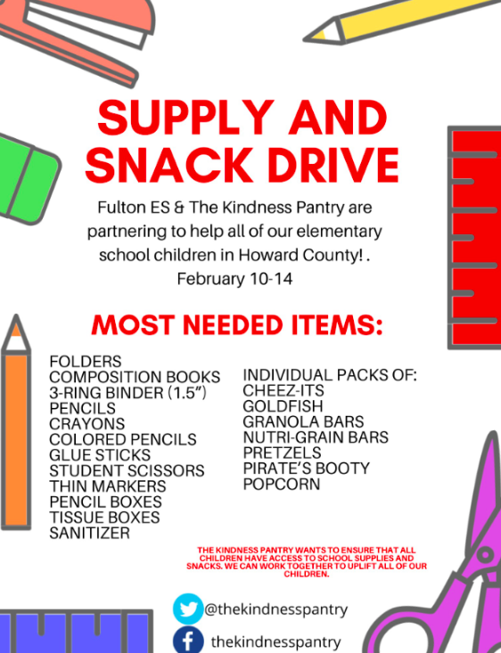

Curriculum Corner
English Language Arts
Have you been to Barnes and Nobles lately or perhaps when you visited the Book Fair and your child picked out a graphic organizer to bring home? Did you look at the cover or skim through the pages and think- this looks like a comic strip or includes cartoon characters? This article shares insight on how graphic novels help develop critical skills for our students.
Math
There are several various strategies that our children are learning that may be unfamiliar to adults that did not learn these skills when in elementary school. If you happen to find yourself frustrated with trying to help with homework, because you are not sure how the strategy works you are not alone. This link provides you an opportunity to watch a short video on the various strategies that your child is learning in the classroom. Additionally, there are practice problems that you can do together. Once at the site, just type what math skill your child is working on in the search field and you will find videos and practice problems.

Bully Buster Bulletin
Here is some information from the Bully Busters!!
Just a reminder that we meet with students regarding feelings and behaviors that may impede learning,
development, and overall health and wellness. Some of these topics may include, but are not limited to, the
following:
- Grief (Loss of a family member, relationship, pet)
- Friendship struggles
- Changing Families (Divorce, separation, difficult relationships, moving)
- Improving strategies for self-control
- Managing anger and frustration
- Developing age-appropriate social skills
- Building confidence and self-esteem
- Navigating disappointments and difficult experiences
Now that first quarter report cards have been nestled in the hands of families for a few weeks, you have likely
seen the latest report card template reflecting the following learning behaviors:
- Demonstrates Interpersonal Skills
- Demonstrates Responsibility
- Demonstrates Perseverance
- Demonstrates Collaboration
- Demonstrates Initiative
Consider having ongoing conversations with your child(ren) to make connections with learning behaviors across environments. This process can support a higher level of understanding, application, and long-term transfer of the behaviors. For instance, discuss the meaning of responsibility and how it applies to the child’s role on the sports team (arriving on-time to practices and games, being dependable, putting forth best efforts, encouraging teammates, etc.). Allow your child(ren) to explain how perseverance and collaboration may also play a role in extracurricular activities.
Thanks to everyone who donated to Helping Hands! A special thanks to Good Hope Church, Grace Community Church, St. Paul's Church, and the Howard County Police Department for their donations for Thanksgiving and Helping Hands! Your gift donations were so generous and helped make the season brighter for some of our families! We hope all of our families at FES have a wonderful holiday season!

Upcoming
January 30 Conference Scheduling Opens
February 3 Report Cards sent home
February 4 No School
February 7 Black out Spirit Day; Unplugged Family Game Night 6:00pm
February 10th- 14th Kindness Week
February 13th 100 Day
February 13 & 14 Parent/Teacher Conferences
Early Dismissal at 12:55 p.m.
February 17 No School- President's Day
February 19 PTA Meeting, 7:00pm
February 20 Class Pictures
February 29 Unheard Perspectives
Full Calendar

Connect with our PTA
Our PTA is a terrific partner to our school. Learn about the many ways they help support Fulton and strengthen our community- as well as how you can get involved.

Provide us Feedback
We always appreciate input on how we can improve. Please share your thoughts and suggestions here. We love to hear from you!

