HAMMOND MIDDLE SCHOOL
6TH GRADE VIRTUAL PARENT ORIENTATION 2021
(All new students and students from the following schools should attend: FES, GCES, HES, and AES)
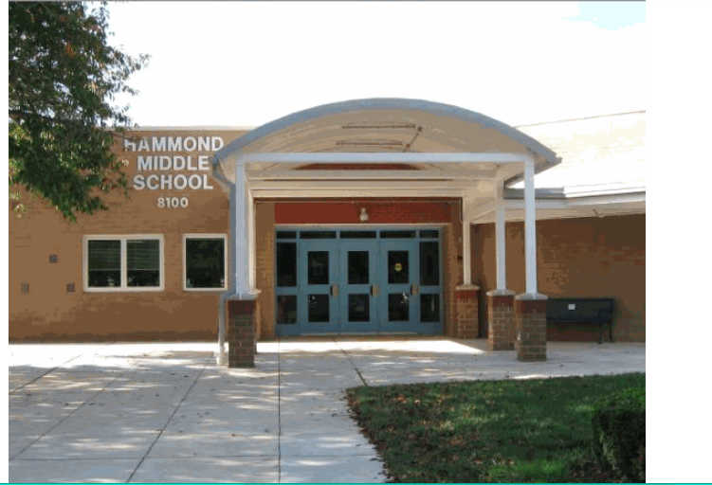
WHO: HMS PARENTS OF INCOMING AND RISING 6TH GRADE STUDENTS

WHAT: PARENT ORIENTATION NIGHT

WHEN: THURSDAY, JANUARY 21, 2021 AT 6:00 PM

WHERE: VIRTUAL HAMMOND MIDDLE SCHOOL GOOGLE MEETING

WHY: WE ARE LOOKING FORWARD TO MEETING YOU AND SHARING INFORMATION
REGARDING HMS PROGRAMS AND PLANS FOR TRANSITIONING
INTO 6TH GRADE

JOIN WITH GOOGLE MEET
meet.google.com/krb-mujw-yzi
JOIN BY PHONE
+1 919-636-9963 PIN: ‪734 324 972#

THE AGENDA FOR THE EVENING SESSION IS POSTED BELOW:

5:30 PM- MUSIC DEPARTMENT INFORMATION MEETING
meet.google.com/nvo-ramu-ort
BAND ORCHESTRA AND CHORUS PRESENTATION
- POWERPOINT
- REGISTRATION
- Q&A
We invite all families to attend to learn more about Band, Orchestra, and Chorus at HMS.

PARENT ORIENTATION

6:00 PM-
- WELCOME BY THE PRINCIPAL, DR. AARON DALE
- ROCKY SEAGROVES, TEAM LEADER
- VIRTUAL INTRODUCTORY MEETING OF TEAM SIX (6)
- GT RESOURCE TEACHER AND SCHOOL COUNSELOR

6:30 PM- POWERPOINT PRESENTATION

QUESTION AND ANSWER SESSION

Hammond Middle School

