The Falcon Flier

Together We Empower

Today & Tomorrow

May 27, 2020

Message from Dr. Burks...
Dear Fulton Families,
Can you believe almost 1/2 of the quarter is behind us? It is a little hard to believe! During this time, students have learned how to mute and unmute themselves in Google Meet, navigate Canvas, and not only log-in but engage in online tools such as Dreambox and Lexia Core 5. Parents and guardians- we thank you! Without your partnership and support, our students would not be as far along as they are.
Our staff is working extremely hard to not only deliver great learning to your child(ren) digitally but also learning these tools themselves, while still creating a school community in which students are proud to be apart of. It has been exciting to have students engage in not only check-ins where they are discussing recently read books or sharing how they solved a math problem, but also seeing their smiles and hearing their laughter as they engage in our ABC Countdown to the Last Day of School activities. Please be sure to check out Fulton ABC Countdown for upcoming activities!
This has truly been a collaborative effort where we have all worked together to make this a successful, engaging and meaningful experience for our students. Let's continue to work together to end this year strong!
Warmly,
Dr. Burks

Announcements

Get ready to celebrate our 5th graders!

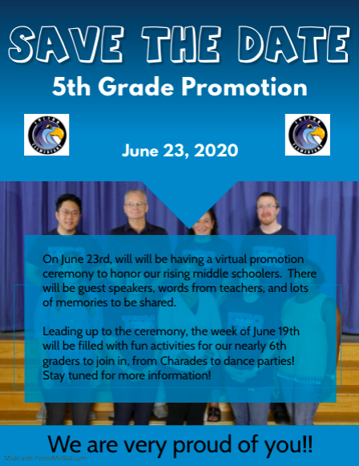

Student/Family Item Pick-up & Drop-Off:
Plans are being made for students and their families to drop off important items from home to school, as well as for the pick-up of very important items that were left at school. Please note that there were many non-essential items left at school, and these will be given to students when schools re-open. Our plans and the timeline for picking-up and dropping off important items will be shared as soon as it is available.

Summer 2020 Online Programming
Summer learning experiences are valuable in helping students stay engaged and maintain skills over the summer break. In compliance with state and local guidelines, all HCPSS 2020 summer programs will be offered online. Virtual programs will have a modified schedule that incorporate both live and digital content that will be accessed online. More information to come.

Mark your Calendars
HCPSS has identified four inclement weather make up days- all of those have been used plus two additional days. HCPSS has applied for a waiver for five days with the Maryland State Department of Education. If the waiver is granted, which we fully anticipate it will be, the last day of school for students will be Tuesday, June 23, 2020. We will update families and provide last day scheduling information as soon as the final decision is announced.

From the Media Center
At this time the Fulton media center is not collecting library books. Please keep them in a safe place until schools reopen in the Fall. Students can return their books to any HCPSS school library or the Howard County Public Library when schools open. Happy Reading!

Do you have a rising kindergartener or have a new neighbor whose children will be joining our FES family next year? Here is how to register...
Parents/guardians of new incoming student and those entering kindergarten in the 2020-2021 school year (who are not already enrolled) will begin the enrollment process online, followed by completion of the registration process via a virtual meeting. If you have not began the process yet, please use the details on our website to start registration. If you have already began, our Front Office staff will be in touch to schedule a meeting with you in order to complete the process virtually.
Full Calendar

Curriculum Corner

Clarification of Participation & Grading for 4th Quarter:
The information below provides clarification of the HCPSS expectations for attendance and grading during 4th quarter. This information is in addition to the information previously shared via the HCPSS website.

Attendance Requirements for Distance Learning
Students will be marked "present" for the week if they do at least ONE of the following each week:
- Attend one virtual check-in (ELA or math)
- Engage in Lexia Core5, or
- Engage in Dream Box

Academic Expectations
Students are expected to participate in 1-2 hours of learning activities each day which includes:
- Lexia: Core: 75 minutes per week / 15+ minutes per day
- DreamBox: 75 minutes per week / 15+ minutes per day
- Daily Teacher Video & ELA, Math, or SEL Task: Approximately 20 minutes
- Science, Social Studies or Health: Approximately 20-30 minutes (Choose daily)
- Related Arts: Approximately 20-30 minutes (Choose an activity daily

Grading
Students will receive a Pass (P) for each content area if they complete at least 50% of the assignments by the end of the quarter. This is 50% of each content area:
- ELA - 263 minutes of Lexia Core 5
- Math - 263 minutes of Dreambox
- Science - Press the submit button 3 out of the 6 weeks after completing the activity/assignment
- Social Studies - Press the submit button 3 out of the 6 weeks after completing the activity/assignment
- Health - Press the submit button 3 out of the 6 weeks after completing the activity/assignment
- Art - Press the submit button 2 out of the 5 weeks after completing the activity/assignment
- Music - Press the submit button 2 out of the 5 weeks after completing the activity/assignment
- Technology - Press the submit button 2 out of the 5 weeks after completing the activity/assignment
- Media - Press the submit button 2 out of the 5 weeks after completing the activity/assignment
- Physical Education - Press the submit button 2 out of the 5 weeks after completing the activity/assignment
If students do not complete these minimums, they will receive an Incomplete (I). If students receive an Incomplete (I), they will have until September 15th to complete the minimums and have their grade changed to a Pass (P).
Please see a visual of these clarifications below:
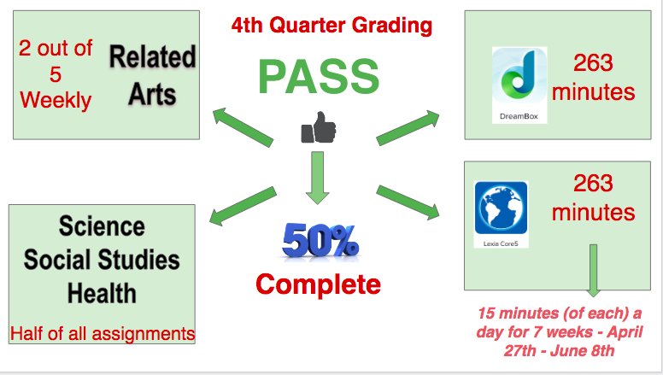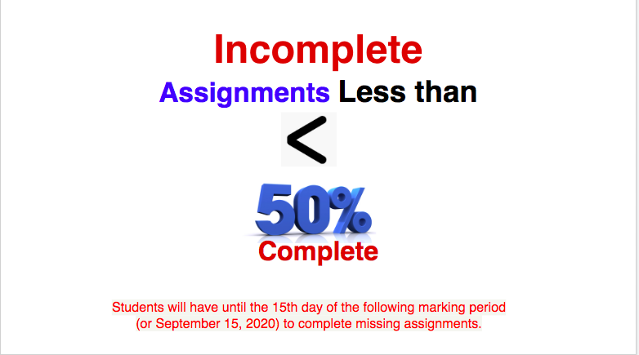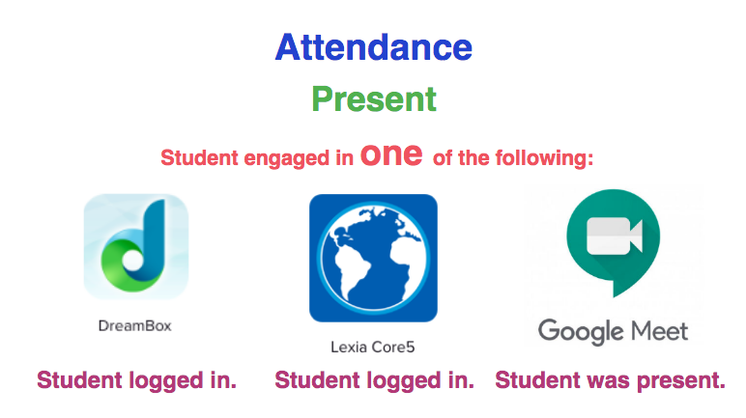

Looking for ways to support your child with Dreambox?
Set up the Dreambox Family Dashboard to learn more about what our child is learning, how they are progressing through the lessons and are his/her weekly goals being met.

How do I know my child has submitted
their assignment?
As was previously shared, students now have a completion button to press as they finish their
lesson activities for science, social studies, related arts, math, writing and SEL. Parents can
monitor and check their child's completion of these tasks after logging into their child's
Canvas page in 2 ways:
1st way:
- Click on Language Arts Canvas Course (you can do the same thing for other subject areas)
- Click on "Modules" on the left hand side
- If you see a 'rocket ship', it indicates it is a quiz. Click on the title aligned to the rocket ship. If you no longer have a blue 'take the survey' or 'take the quiz' button, it means your child has completed the task. From there, you can also look at 'Submission details' on the righthand side of the screen. If it says 'current score: 1 out of 1', then it means the task has been submitted.
2nd way:
- Click on Language Arts Canvas Course (you can do the same thing for other subject areas)
- Click on "Grades" on the left hand side
- Once you have clicked, you will see all of the assignments that have been provided to your child for Language Arts (or whatever subject you selected) with a due date of June 14th (aligning with the initial last day of school- June 15th). There you will see a score: 1 out of 1 means that your child has submitted the task or a 0 means the task has yet to be submitted.
- At the top of screen, you can toggle between different subject areas.

Bully Buster Bulletin

PBIS Update
- Please tell returning students to KEEP their Falcon Feathers for next year. The PBIS committee will come up with a way to use them when we return to the building. For example, maybe a big raffle drawing for prizes!
- Remember to continue to show the 3R's (Respectful, Responsible, and Ready) while learning at home. For example, a way to be Respectful is to stay focused and on task during live check-ins with your teachers! The chat box should only be used for on-topic conversations as it can be very distracting to others who are trying to pay attention when there's too many comments.
Please continue to reach out to our Student Services Team (Beth Shields & Jessica Wilson- School Counselors or Maria Brickley- School Psychologist) for Emotional Support for students (e.g., frustration with online programs/activities, finding that good spot to learn, worried about work or grading). You may email us to set up an appointment. Additionally, the School Counselors are now able to have Lunch Bunches! Let us know if your child is interested!
Counseling Connection Newsletter - The HCPSS Elementary School Counseling Connection Newsletter is a great resource for students and parents to read together. Included in this latest issue of the School Counseling Connection newsletter are self-care ideas and fun activities for home.

Connect with our PTA
Our PTA is a terrific partner to our school. Learn about the many ways they help support Fulton and strengthen our community- as well as how you can get involved.

Provide us Feedback
We always appreciate input on how we can improve. Please share your thoughts and suggestions here. We love to hear from you!

